**Project Overview:**

Every student who goes to school cares about his grades. Almost every class has a different way to make up a final grade. Some classes have quizzes some have projects and even some has Programing Assignments. They also have different percentages that changes depending on the class. It can be very difficult to keep track of your grade and know where you are standing academically. By using our app it is not that hard anymore. By this GPA calculator you are able to enter all your courses and edit how your teacher grades you. With the help GPA calculator you will always know where you are standing in the class and how well you should do. By using persistent data you don't have to re enter all the courses again every time you close the application.

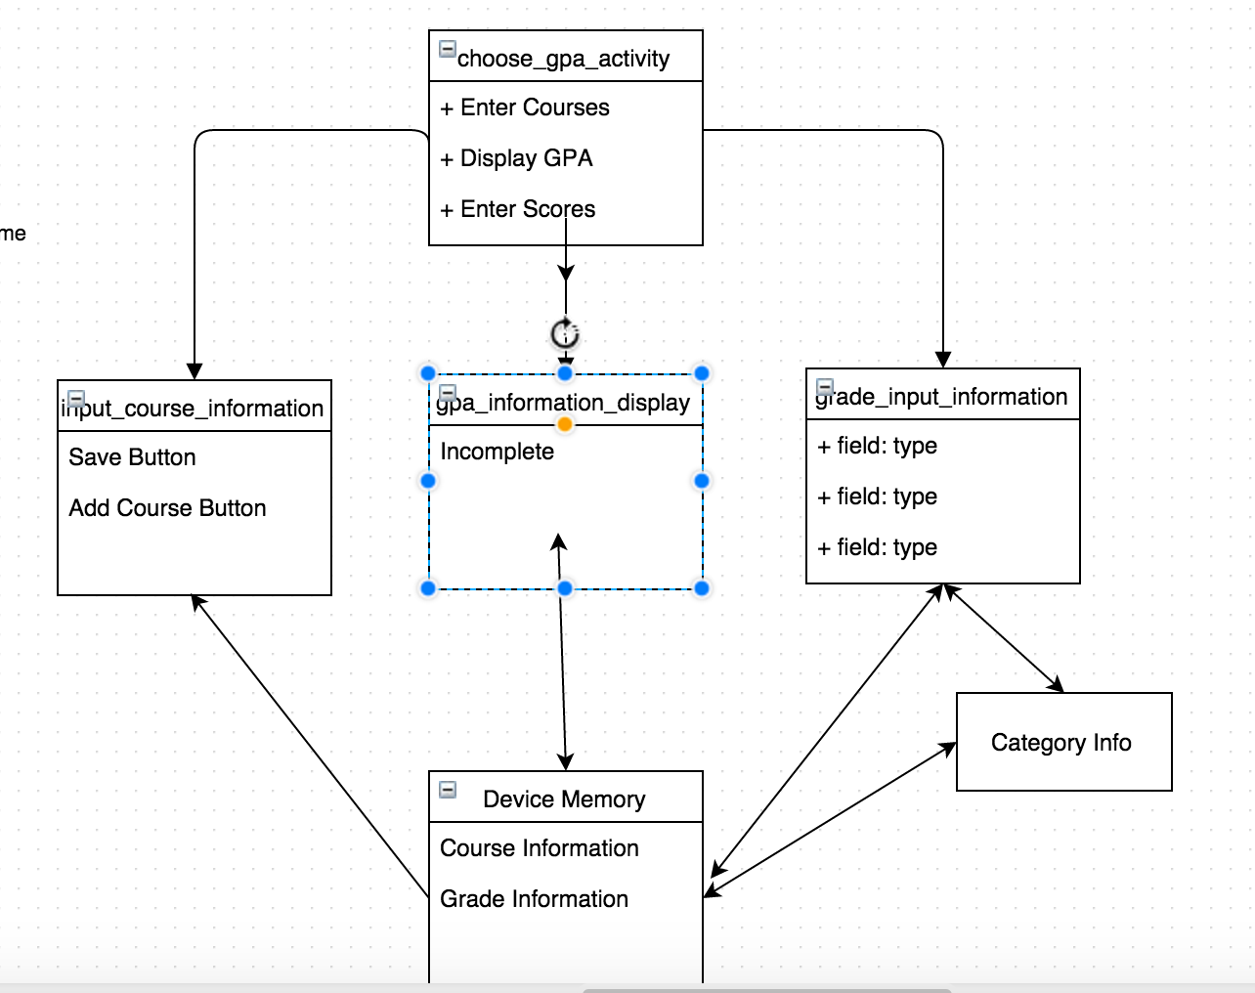

**Back-End:**

The main screen is organized in a ListView displaying three options to change to an activity. The button press will be received by the application and the application will be redirected based upon the string returned from the button press. In the course input screen users have the option to enter information into an editable text box. Following a button press the data stored in these text boxes will be displayed in order they were inputted in. If a false input was made the data can be removed by using the trash can button. This button works by determining which button was pressed and from there it determines where data is present based upon a series of selection statements. Following the press of the save icon the information in the display will be sent to the device memory for later storage. The grade_information_input follows much of the same pattern. However the intended design was for the grades to be stored based upon the course selected but due design limitations this was not completed. The GPA information display was also not completed.

**Front-End:**

The main GUI responds to user input through the determination of which button was pressed. The button press information also corresponds with a string that is selected against to provide a change in activity. The input_course_information and grade_information_input follow much the same design pattern with button presses doing certain actions detailed above. All layouts were done using a combination of RelativeLayout for the main layout with GridLayout containing the information.